*Step 1 : create a chart by name ajay*

helm create todo

*step 2 : check the default values of the chart*

helm show values todo

*step 3 : check what helm is going to deploy*

helm install devops todo --dry-run

*step 4 : check the default nginx image version*

notice the nginx image that is going to install is nginx:1.16.0 and also port number 80 ( todo app listens on 8080 so we need to modify

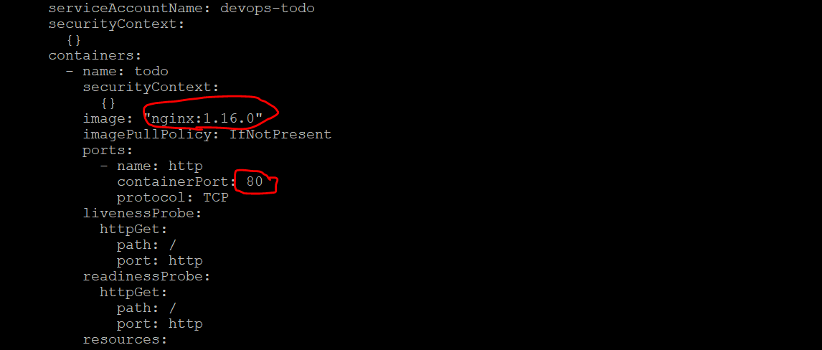

*step 5 : modify the nginx image with latest*

vim todo/values.yaml

Provide ur repo name

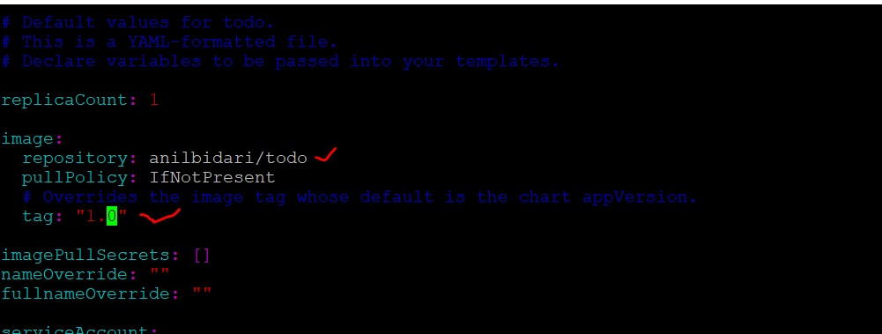

On line 40 – change to 8080

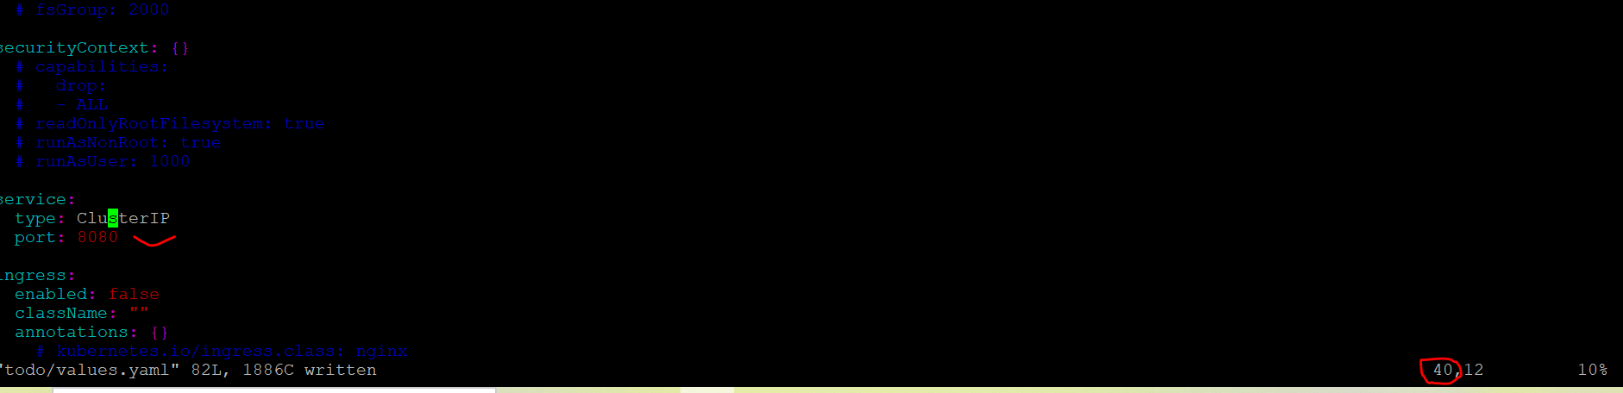

vim todo/templates/deployment.yaml

in line 38 change port from 80 >> 8080

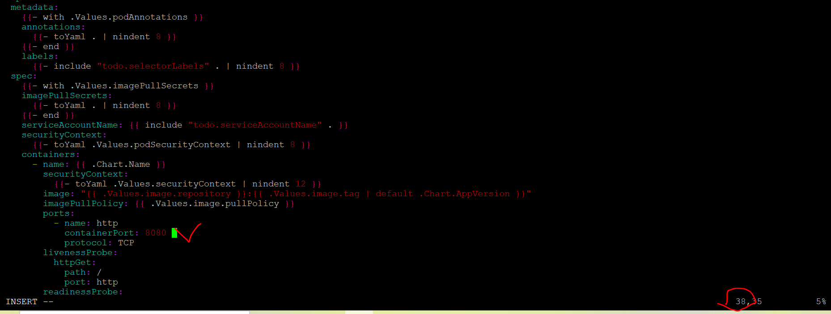

helm install devops todo --dry-run

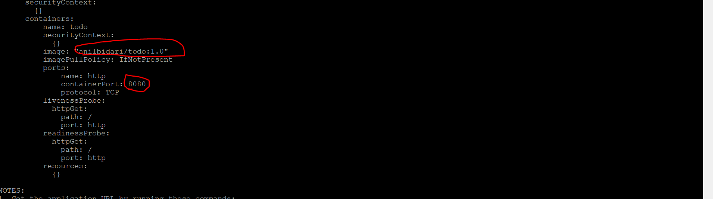

Expose with cluster ip

helm install devops todo

kubectl get svc



Notes :

You can access service only within the cluster

Ideal for no internet facing microservices which need not expose to external world

Expose with node port

vim todo/values.yaml

Modify line 40 to NodePort

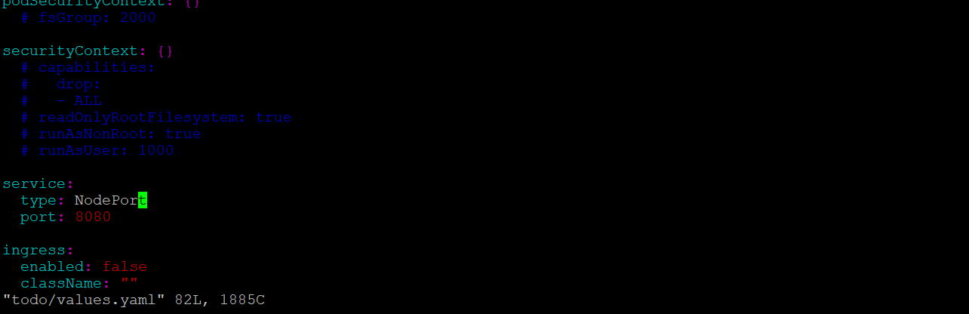

helm install devops3 todo

kubectl get svc

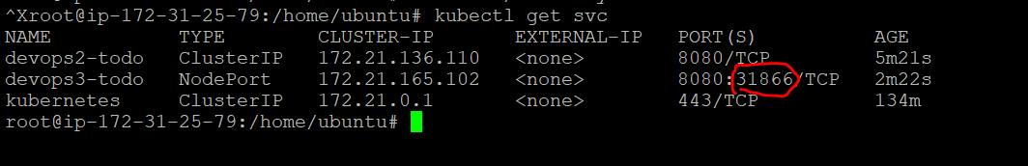

You access app via nodeip:port number

